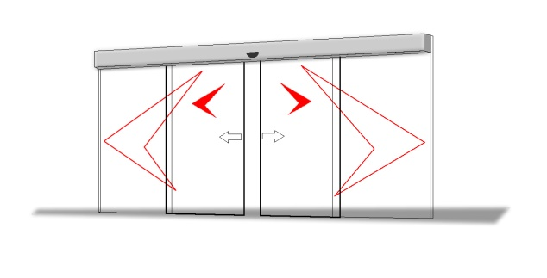

AUTOMATIC DOOR SPECIFICATION (STRUCTURAL MODEL)

RUBEK STRUCTURAL Automatic Sliding Door Operator - built for high traffic commercial applications using heavy framed or frameless doors. Used for all door types. This track housing should NEVER need removal or replacement as a maintenance item for the LIFE of the building.

The equipment will incorporate the following

- The automatic bi-part/single sliding door operator is to be a 240 Volt fully electric Rubek Structural (6mm housing) operator housed in a fully extruded beam and pelmet able to accept doors up to a total of 500kg.
- Maintenance-free, self-lubricating gears to be supported at each end by fully sealed steel roller bearings fully enclosed in a die cast aluminium housing to prevent exposure to dust and dirt and to prevent leakage or dissolution of lubricant.
- Polychloroprene Kevlar reinforced HTD tooth belt 20mm width of 1500kg tensile strength.
- The controller is to be capable of being programmed by any suitable service company personnel without the need for specialist programming equipment. On-site adjustment should be able to be carried out by suitably trained trade personnel as and when required. The controller status should always be illuminated on an LED display for easy diagnosis of the door operation.
- Connections for Building Management Systems control and monitoring, fire services and security.
- Easily removable hard anodized aluminium track.
- In the event of a power failure the controller should still function as normal on backup battery and in the event of a low battery condition should sound an audible low battery alarm.
- Constant battery monitoring for charging and battery status and failing battery. The controller shall supply a regulated and current limited self-charging circuit to keep the battery at its optimum level of charge and to increase the useful life of the battery.
- Expandable battery backup to support normal operation for a minimum of 8 hours.

Locking (Note to specifier: Choose one lock method and delete the other)

- The operator is to be fitted with a failsafe motor lock device directly locking the rotor shaft thus preventing locking failures due to door misalignment.
- After-hours the doors are manually switched to the off position and manually locked by a key via a standard lockset key and snib mechanism.

Safety

- Independently adjustable variable speed control for both open and close speeds as well as slow final speeds. Brake, torque and dwell timer adjustments should allow for full adjustment of settings capable of being set to comply with AS5007-2007.
- To automatically reverse the door in both open and close cycles with adjustable sensitivity.
- To automatically stop on opening AND closing, back up the door slowly and retry until obstruction is cleared. In the event that the obstruction is not cleared the door should switch into safety standby mode.
- Fully adjustable speed control with independent settings for open, close and braking.
- Intermediate opening widths.
- Self-monitoring of all electronic safety devices to comply with BCA Section D2.19.
- The operator is to be capable of full interface with the fire alarm system to provide both unlock and open facility or open only during normal operation (if not locked) on fire alarm.

Actuation: (Note to specifier: Delete non applicable items as required)

- Microwave movement sensors with adjustable sensitivity, range and selectable zone detection pattern. The sensors are capable of providing one metre sideways detection from the centre line of the installed unit. These detectors must provide selectable failsafe or fail secure operation.
- Dual set of photoelectric cells or curtain sensors to keep door(s) open if obstructed as per the current Australian Standards. Closing force of doors should not exceed 130Nm of force.
- Push to exit button.
- Open key-switch.
  - Internal mode selector switch.
  - Security Interface – Ability to provide operational data and be fully compatible with card reader, time lock, time clock control and key entry switch and break glass switch.
  - Panic button – In the event of an immediate security requirement an internal panic button can activate a programmable door closure where the doors will remain closed or locked until reset from the door control switch. Fitted at the counter.
  - Break Glass switch.

Warranty

The Automatic Door Operator should be covered by a two year parts and one year labour warranty including after hours from date of commissioning. The housing will be covered by a lifetime warranty as per our standard terms and conditions.

Building Code Compliance

Must fully comply with the current edition of the Building Code of Australia (BCA) Sections D2.21 and D2.19. Particular attention will be made to ensure door operators comply with D2.19(B)(iv)(A) If fitted with a door which is power-operated - it must be able to be opened manually under a force of not more than 110 N if there is a malfunction or failure of the power source; Note: malfunction applies to the whole operator and not just the power source.

Australian Standards

It is recognized that AS5007-2007 is not referenced in Government legislation or the BCA and is only a guideline and therefore not a compulsory Standard and also that full compliance is not possible as there is no NATA laboratory in Australia that can test the safety aspects of any automatic door operator. Compliance with all relevant safety aspects of AS5007-2007 is required for this specification.

Rubek Automatic Doors – 9302 3200 – www.rubek.com.au – sales@rubek.com.au

